Automation Task Guidelines

Please prepare the following use cases and upload them to a public repository (e.g. **GitHub** or **Bitbucket**).

Make sure that test scripts are executable on a local machine. Add additional information in case any software/framework is required to run those test cases (installation script is preferred).

Also, advice in form of a short **README** how to execute those test scripts.

UI Tests

Using any test automation framework and any programming language (except play/record tools), please do following:

Test Case 1

1. Navigate to the URL https://www.sogeti.com/

2. Hover over Services Link (see Image below) and then Click **Automation** link.

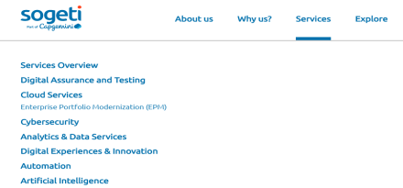 3. Verify that **Automation** Screen is displayed, and “**Automation”** text is visible in Page.

4. Hover again over Services Link. Verify that the **Services** and **Automation** are selected (see Image below).

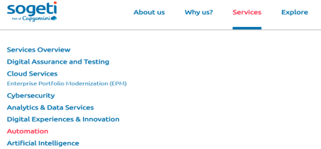

Test Case 2

1. Navigate to the URL https://www.sogeti.com/

2. Hover over Services Link and then Click **Automation** link.

3. On **Automation** Page, scroll down to the **Contact us** Form.

4. Fill the **First Name, Last Name, Email, Phone** and **Message** fields with **Random Generated Data.**

5. Check the **I agree** checkbox.

6. Then Click **SUBMIT** button.

7. After clicking **SUBMIT** button the form is submitted and Thank you message is displayed. Assert the Thank you message.

**# Note**: While automating a Test Case, if you are encounter a test step which cannot be Automated. Automate the Test till that Step and please explain in comments in why it is not possible to automate the Test Step? What are the possible workarounds to Test such Test Case?

Test Case 3

1. Navigate to the URL https://www.sogeti.com/

2. Click the Worldwide Dropdown link in Page Header.

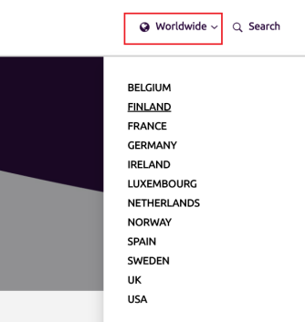

3. A Country dropdown list is displayed. These are the Country specific Sogeti links. 4. Assert that all the Country specific Sogeti links are working.

API Tests

1. Write API Test for http://api.zippopotam.us/de/bw/stuttgart

• Verify that the response **status code** is **200** and **content type** is **JSON**.

• Verify that the **response time** is below **1s**.

• Verify in Response - That "**country**" is "**Germany**" and "**state**" is "**Baden-Württemberg**". • Verify in Response - For **Post Code** "**70597**" the **place name** has "**Stuttgart Degerloch**".

2. Write API Data Driven Test for http://api.zippopotam.us/{country}/{postal-code} In Data

Driven Test - replace "**Country**" and "**Postal Code**" in above Test URL from Test Data. **Test Data:**

| Country | Postal Code | Place Name |
| --- | --- | --- |
| us | 90210 | Beverly Hills |
| us | 12345 | Schenectady |
| ca | B2R | Waverley |

• Verify that the response **status code** is **200** and **content type** is **JSON**.

• Verify that the **response time** is below **1s**.

• Verify in Response - "**Place Name**" for each input "**Country**" and "**Postal Code**".